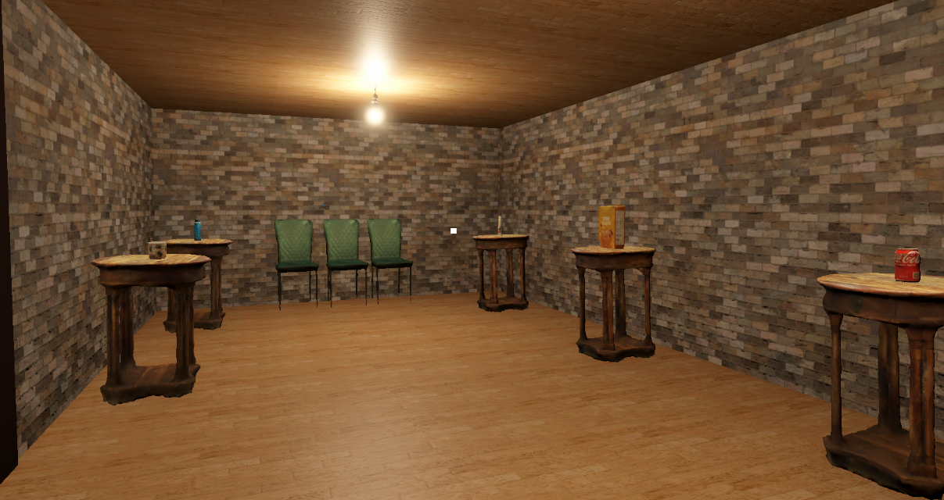
3D Reconstructive Techniques
Design Document - CM2121

Isaac Naylor
RGU
2507509

Contents
UN SDG Theme and Overview and Project Plan 2
Mood boards/inspiration 3
Sketches 4
Task List 6
Scanned Objects 7
SFX/VFX 7
Images/Assets/Polycam Links 7
Review 8
References 9

UN SDG Theme and Overview and Project Plan
For this project, I have chosen the UN Sustainable Development Goal “Sustainable Cities and Communities” (SDG 11) as the core theme. The project aims to explore sustainability through the lens of everyday urban life by presenting common household objects as museum artefacts within a 3D virtual environment created in Unity.
The experience takes the form of a virtual museum tour, where the player can freely navigate a series of rooms containing pedestal-mounted objects. Each object represents an item commonly found in daily life within modern cities. By interacting with these objects, the player can inspect them closely and access information about their material composition, environmental impact, and biodegradability.
To reinforce learning and engagement, the museum experience will conclude with a short interactive quiz, allowing players to test their understanding of the sustainability concepts presented throughout the exhibition.
To support this concept, photogrammetry is used as the primary method of asset creation. All physical objects within the museum, including the exhibited items as well as display elements such as pedestals and barriers, are scanned from real-world objects using Polycam and refined in Blender before being imported into Unity. The surrounding space, such as walls and floors, is constructed using simple planes within Unity with applied textures.

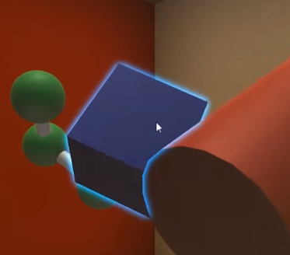
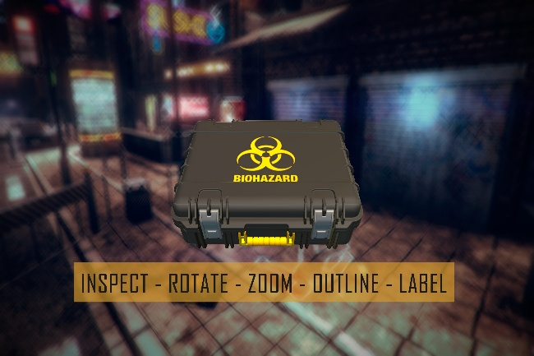
Mood boards/inspiration
This could be an example of the unity 3d “inspection” menu/interface you see in games such as horror games, where my player can walk up to an item, that will glow, and you press E, which will they allow the item to be picked up and rotated etc. Will like to include an information pane on the right or below to give the required information about each item.
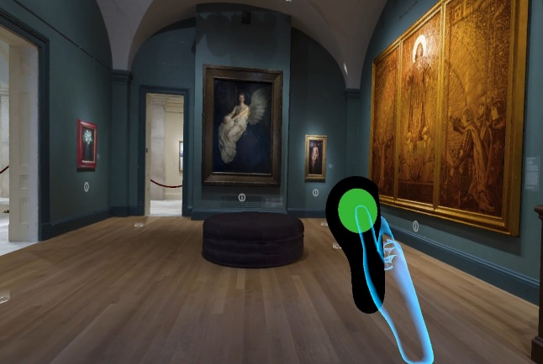
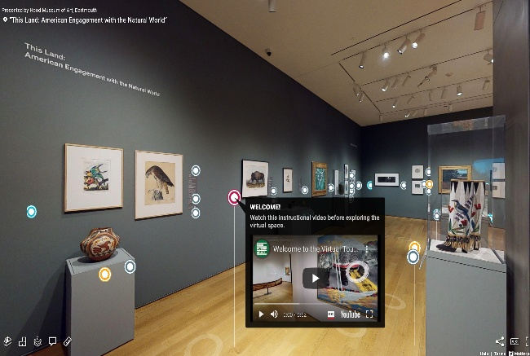

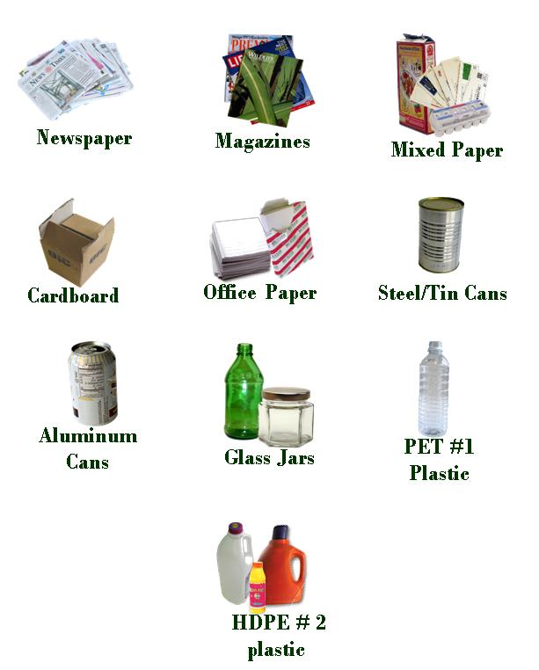
This is an example of the type of environment I would like to create in the 3D space, player can walk about freely, except the items will be 3D scanned from polycam and edited in blender. This here is an example of some of the everyday household items I can include in the scene, potentially a mobile phone or some baby toys also.

Sketches
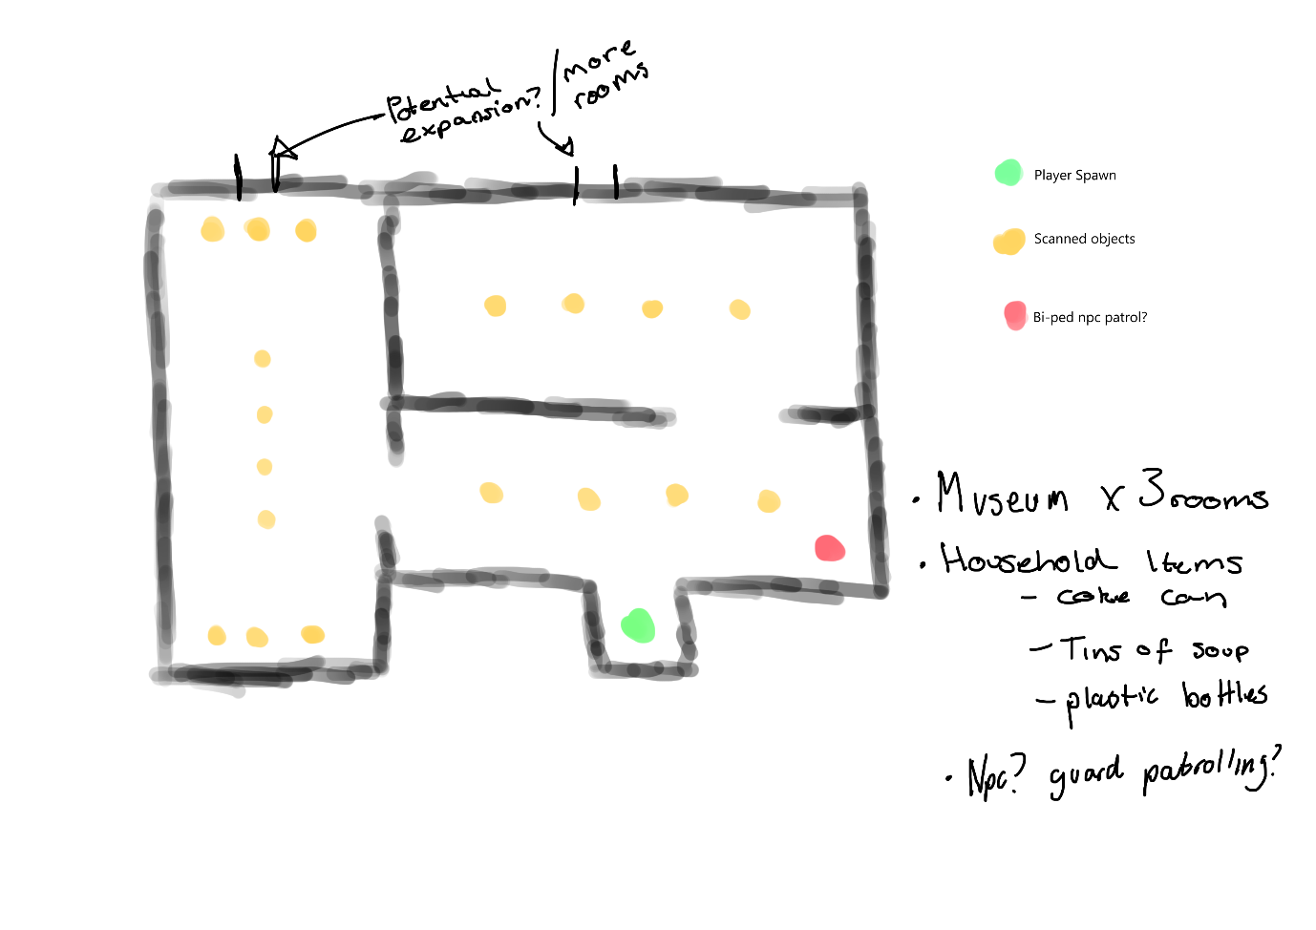
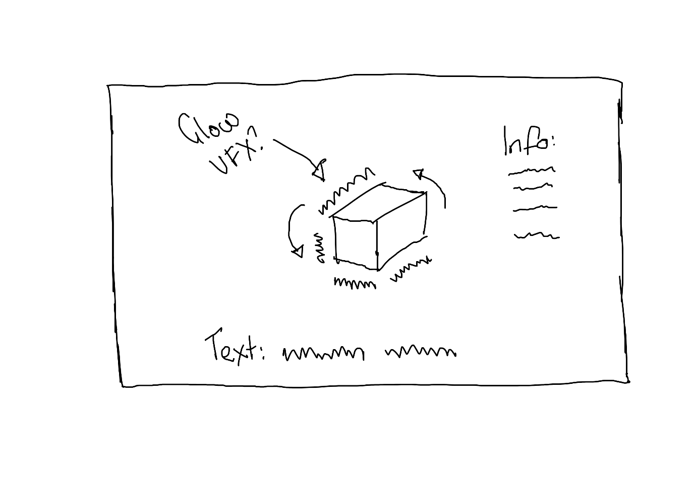
The first sketch demonstrates the potential idea for a level design for the museum. For example, I will have pedestals with items on top of them just like a regular museum would have. I would also like to include a security guard, scanned in from one of my kids’ toys of something like that. This will be merely patrolling the rooms and will have no interaction as of current state. There is a small green indicator of where the player will spawn, and I have decided that it will be a first-person game. The museum will have areas where I could potentially expand upon it like more rooms or items etc. The second image is more of a first-person idea, where you can pick up the items and rotate them to look at them from other angles. There will be more information on certain items like, what they are made of, how long they take to decompose or if they can/cannot and the impact of them on the environment.

Task List
- Research UN Sustainable Development Goal 11 and identify key themes relevant to everyday urban life
- Gather visual references for museum spaces, object display, and interaction design
- Produce initial sketches outlining museum layout and interaction flow
- Select suitable household objects for photogrammetry scanning
- Capture 3D scans of selected objects using Polycam
- Import scanned models into Blender for cleaning and optimisation
- Adjust scale, pivot points, and orientation of scanned assets in Blender
- Export optimised models and textures for use in Unity
- Create the museum environment layout using simple geometry in Unity
- Design and place pedestal structures within the museum space
- Implement player navigation and camera controls
- Develop an object interaction system allowing objects to be picked up, rotated, and inspected
- Design and implement informational UI panels for each object
- Populate the museum with scanned objects and associated data
- Test interactions, navigation, and performance
- Refine lighting, layout, and usability based on testing

Scanned Objects
- Aluminium drinks can
A common single-use item found in urban environments, used to highlight recyclability and material lifespan.
- Plastic bottle (PET)
Selected to represent plastic consumption and its long-term environmental impact.
- Cardboard packaging
Used to demonstrate biodegradable materials and common shipping waste in cities.
- Glass jar
Represents reusable and recyclable materials commonly found in households.
- Food packaging wrapper
Included to highlight mixed-material packaging and the challenges of recycling.
- Toothbrush
A daily-use hygiene item used to explore non-biodegradable plastics in everyday products.
- Electronic accessory (e.g. earphones or charger)
Represents electronic waste and material complexity within modern urban life.
These objects were chosen due to their familiarity and widespread use, allowing players to easily recognise them and reflect on their own consumption habits when encountering them within the museum environment.

SFX/VFX
- Footsteps
- Audible room ambience/hum
- Object inspection audio (pick up/put down)
- Highlight object VFX

Images/Assets/Polycam Links

Review
The initial design proposed multiple rooms and additional elements such as a patrolling character; however, the scope was later reduced to a single room to allow for a more refined and polished experience within the available timeframe.
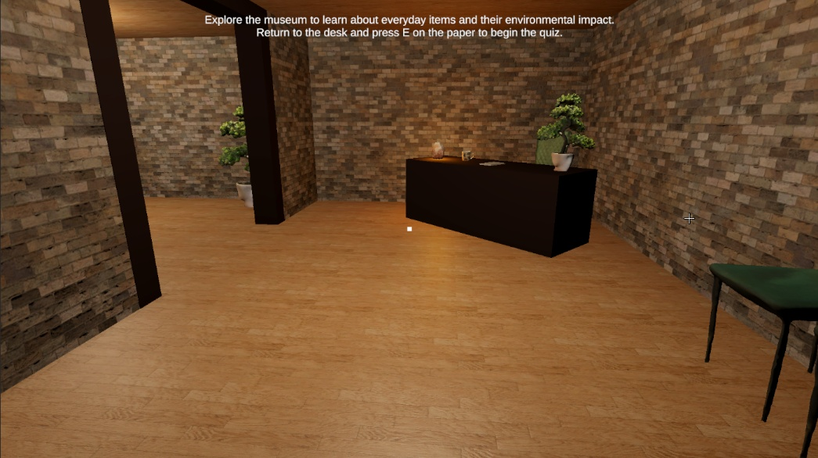
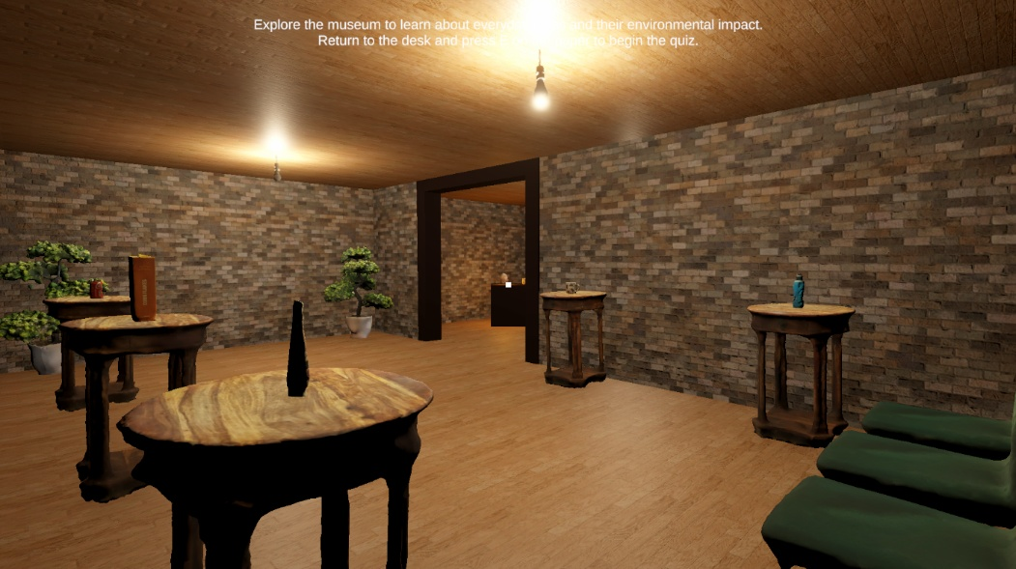
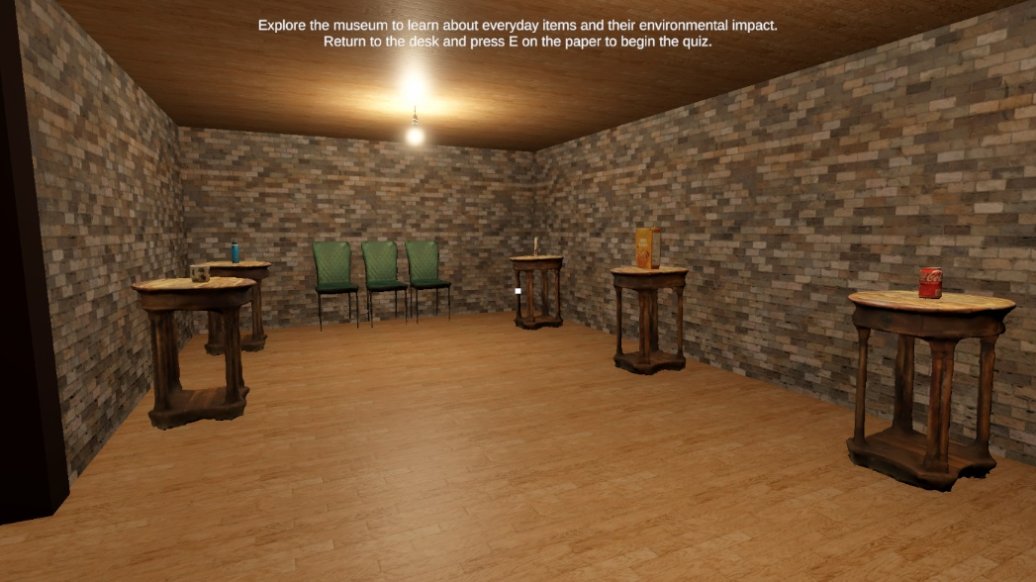

References
Mood Board
Image sources used for visual reference within a mood board. Exact sources unavailable.

Unity Assets
Radio Music / Audio –
https://www.youtube.com/watch?v=qJQPNVxlvXc&list=RDqJQPNVxlvXc&start_radio=1
https://www.myinstants.com/en/instant/children-yay-44890/

Yughues Free Wooden Floor Materials -
https://assetstore.unity.com/packages/2d/textures-materials/wood/yughues-free-wooden-floor-materials-13213
P3D: Outdoor Wall Tile Texture Pack (LR) -
https://assetstore.unity.com/packages/2d/textures-materials/brick/p3d-outdoor-wall-tile-texture-pack-lr-247739

Unity scripts
Inspect/Exhibit Viewer/Exhibit Interactable/Exhibit UI;
Code Monkey - https://www.youtube.com/watch?v=tJ_ycboPFmY&t
CodeFriend - https://www.youtube.com/watch?v=_lEZ4PBw3Co&t
Rytech - https://www.youtube.com/watch?v=K06lVKiY-sY
SpeedTutor - https://www.youtube.com/watch?v=K8p7e0ESauE

QuizManager;
Can With Code - https://www.youtube.com/watch?v=_YFegmzlcT8
The Game Guy - https://www.youtube.com/watch?v=G9QDFB2RQGA
OpenAI (2026) ChatGPT used for debugging assistance and development support. Available at: https://chat.openai.com (Accessed: 30 March 2026).
Player Movement;
Brogrammer1 - https://www.youtube.com/watch?v=1uW-GbHrtQc&t

